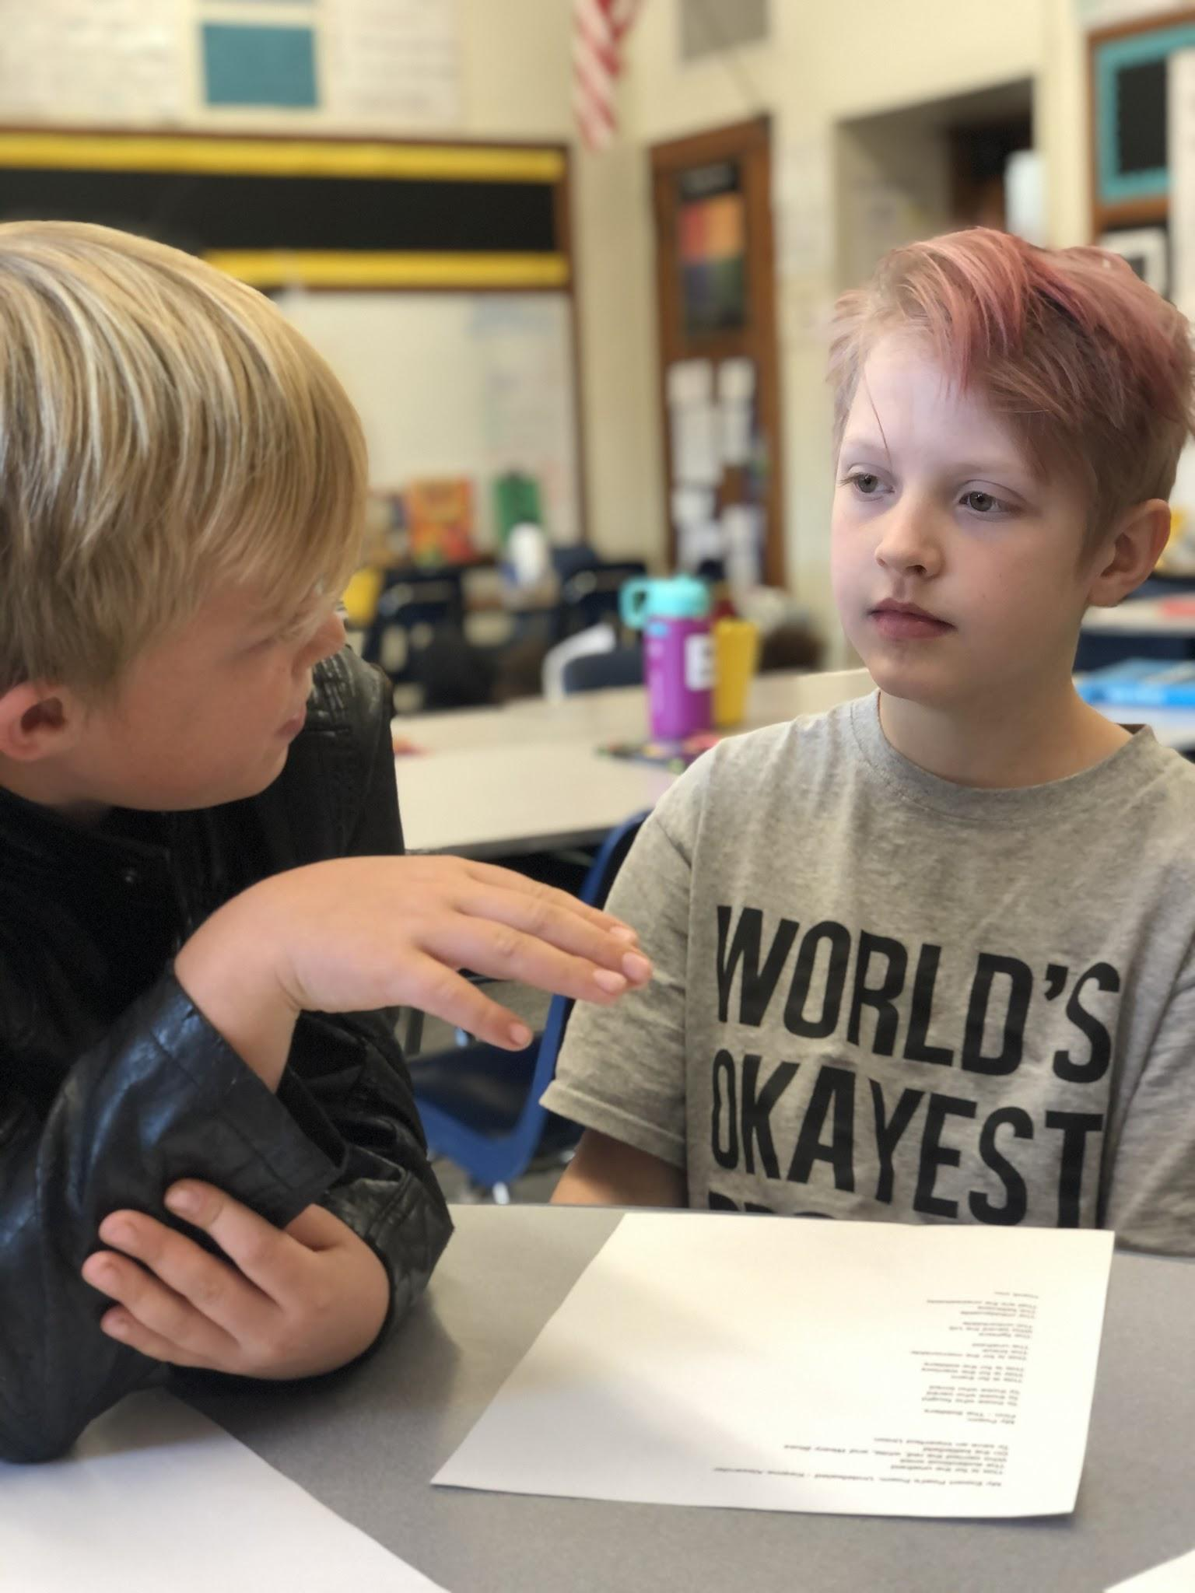
SAVE THE DATE
PBL EXPO IS COMING!!!

When: December 12, 2019
6:00pm-7:15pm

Where: Asbury (start in Auditorium)

Who: 2nd Music, 3rd, 4th, 5th & Art

This is an exhibition of the process and products students have been engaged in over the last few months, please join us!

