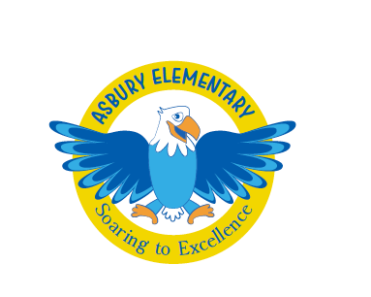
Dear Asbury Community,

Welcome to the start of the 2019 - 2020 school year at Asbury! I cannot express how honored and excited I am to serve this community as your principal. I would like to take this opportunity to introduce myself and share a little bit about me and our vision for Asbury. I grew up outside of Chicago but have lived in Kentucky, Mexico, New Mexico and now live in Colorado. I am married to my amazing husband Rick and we have twin daughters, Sophia and FIanna, who are juniors at East High School this year, go Angels! We also have the best dog ever and her name is Farrah. This school year marks my 13th year in education. I began as an assistant in a Montessori classroom, I have taught 2nd and 5th grade, was Asbury’s Assistant Principal and now I have the privilege of being the Principal at Asbury. I am thrilled to work alongside you all this year.
This coming school year, we are going to achieve great things together. I can promise that Asbury will be a place that is filled with joy, rigor, hands-on experiences and excitement for all. We are committed to excellence and equity for all of our students. We create lessons to address social-emotional intelligence and foster self-directed, respectful and empowered life long learners. Asbury is a community of diverse and vibrant members and we celebrate our inquisitive and engaged learners each and every day. We look forward to sharing more of our vision for the school year at Back-to-School night on August 29th from 6 - 7:30. More information will come to you through School Deets- be on the lookout!
Also, Our 2018 CMAS (state assessment) data is in. We outperformed the district in Literacy and Math and will need to continue to focus on growth in both math and literacy. More detailed information will come out on the student level data in upcoming weeks. Congrats to our Eagles!
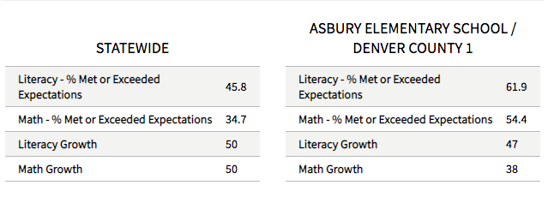
I feel so blessed to lead and serve this wonderful community. It is evident that there is so much passion and dedication to our students. I look forward to a wonderful year ahead. As always, please reach out with any questions- alicia_fajohn@dpsk12.org.

Warm Regards,

Alicia FaJohn
Principal

