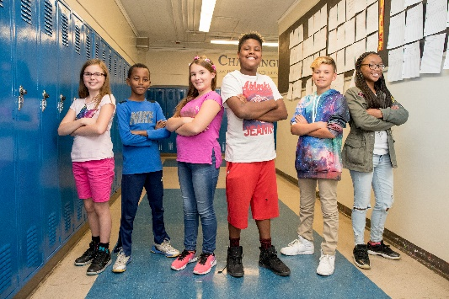http://www.giftedscales.com/denver/http://www.giftedscales.com/denver/

**Tuesday, September 24, 5-7 pm**Vickers Boys and Girls

**Thursday, September 26, 5-7 pm**

Broncos Boys and Girls

**Wednesday, October 2, 5-6:30 pm**

Morey Middle School

***Spanish Translator on Site***

**gt.dpsk12.org**

**720-423-2056**

Join us for a Highly Gifted and Talented Magnet Information Session

**Learn more about magnet sites and the magnet identification  
 process at one of three upcoming informational sessions!**

**Have you noticed that your child…**

* learns subjects quickly?
* gets bored in class?
* displays an unusual intensity or feels emotions deeply?
* has a strong sense of justice and injustice?
* shows exceptional curiosity?