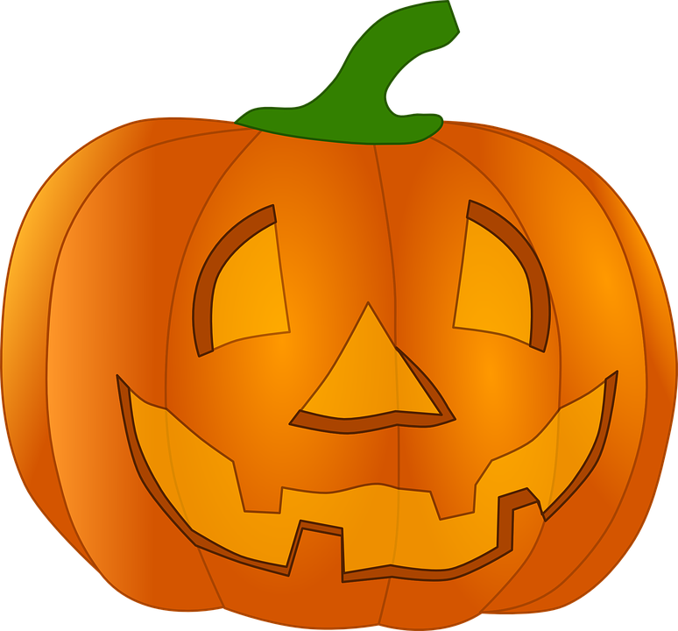

HALLOWEEN CELEBRATION

We will be celebrating Halloween on Thursday, October 31st

In the morning, students should bring their costume in a bag with their name on it.

- 1:45 PM - The students will begin changing into costumes at this time. If parents would like to come at 1:45 they are welcome at this time. Please do not expect to go into the classroom until then.
- 2:00 PM - Halloween Parade - Students will then parade around the track. Parents should gather on the blacktop. In case of Inclement weather please gather in the auditorium and we will parade inside the school.
- Classroom celebrations will be held after the parade. Classroom party volunteers please check with room parents for details.

No costumes or make-up should be worn to school in the morning. Please make sure that costumes are appropriate for an elementary school. No fake blood or weapons are allowed. Even if they are a part of the costume.

