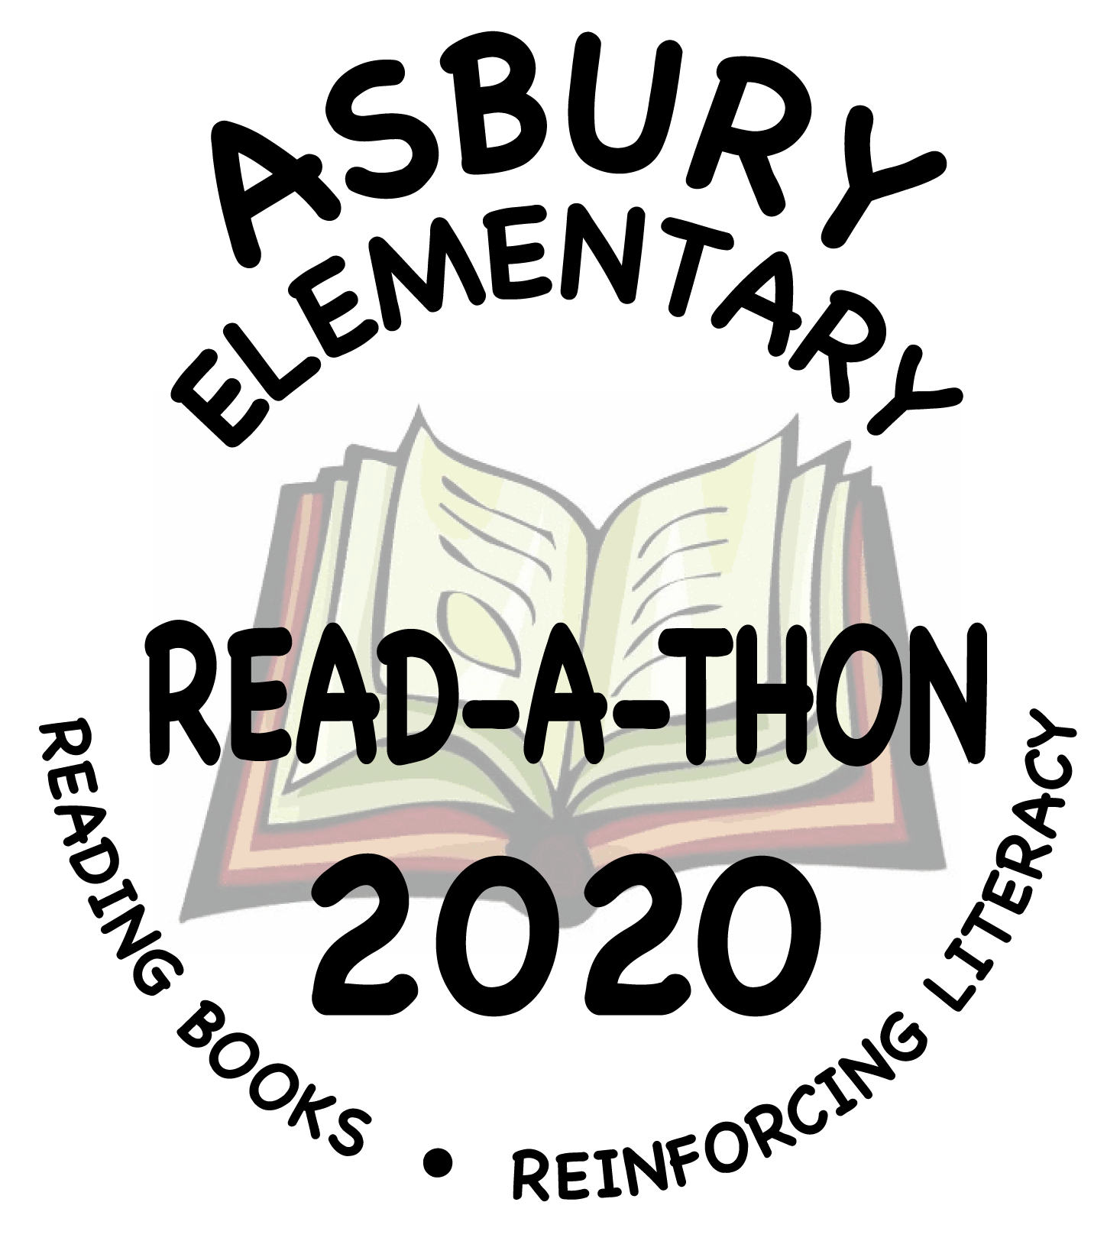
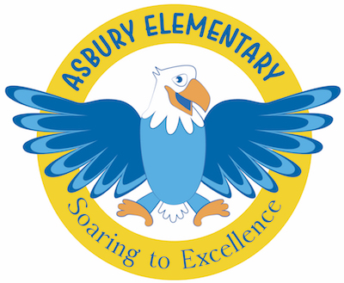

It’s almost time for our beloved Read-A-Thon. Here’s a brief overview:
Reading books – Raising Funds - Reinforcing literacy

- The main focus is literacy and a love of reading. However, there will also be a fundraising component for those that choose to share the information with family and friends.
- Because this unique event is run entirely by parent volunteers, 100% of all money collected will go directly to the Asbury PTSO!
- During Read-A-Thon, students track the minutes they read and bring in a gold “reading feather” the following morning.
- PTSO volunteers will tally the minutes listed on the feathers daily, then post the classroom and all-school progress.
- At the end of reading week, prizes will be awarded based solely on the minutes reported on the feathers. Please make sure your child turns in their Gold Reading Feathers so they can participate in these contests.

The Read-A-Thon information packets will be sent home with each student on Thursday, March 5th.
Reading Days will be March 5th – March 11th.
We’re so excited to celebrate a love of reading with our students!

